MODULE NAME- LOGIN TEST

TEST CASE ID- LOG_1

WEB PAGE URL- <https://studentportal.silveroakuni.ac.in/UMSStudents/Login.aspx>

Scenario ID- 1

TEST STEPS-

| 1) UI is good and attractive |
| --- |
| 2)Enter Username/Enrollment |
| 3)Enter Password |
| 4)Enter Captcha |
| 5)Tap on login |

SCREENSHOT’S-

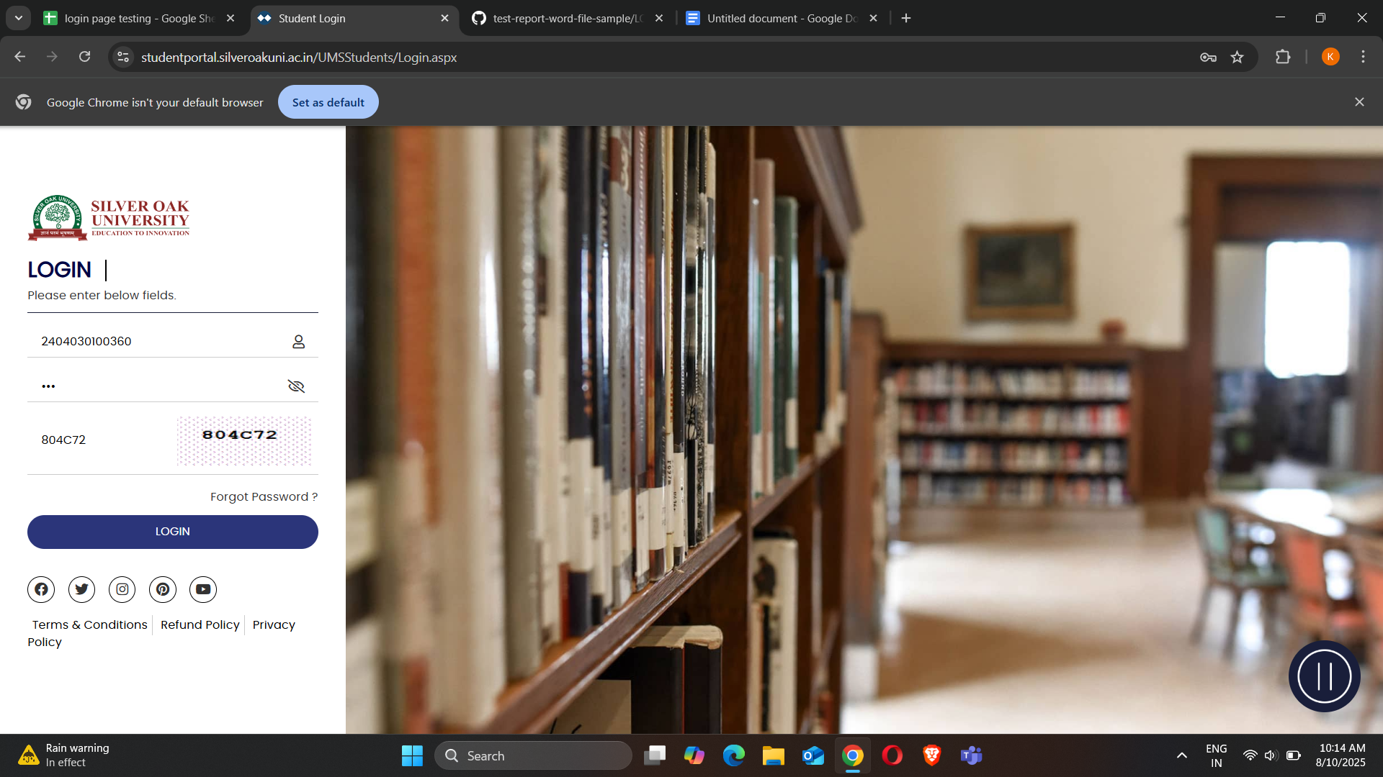

Scenario ID-2

| 1)Enter wrong username |
| --- |
| 2)Enter wrong password |
| 3)Enter Captcha |

SCREENSHOT’S

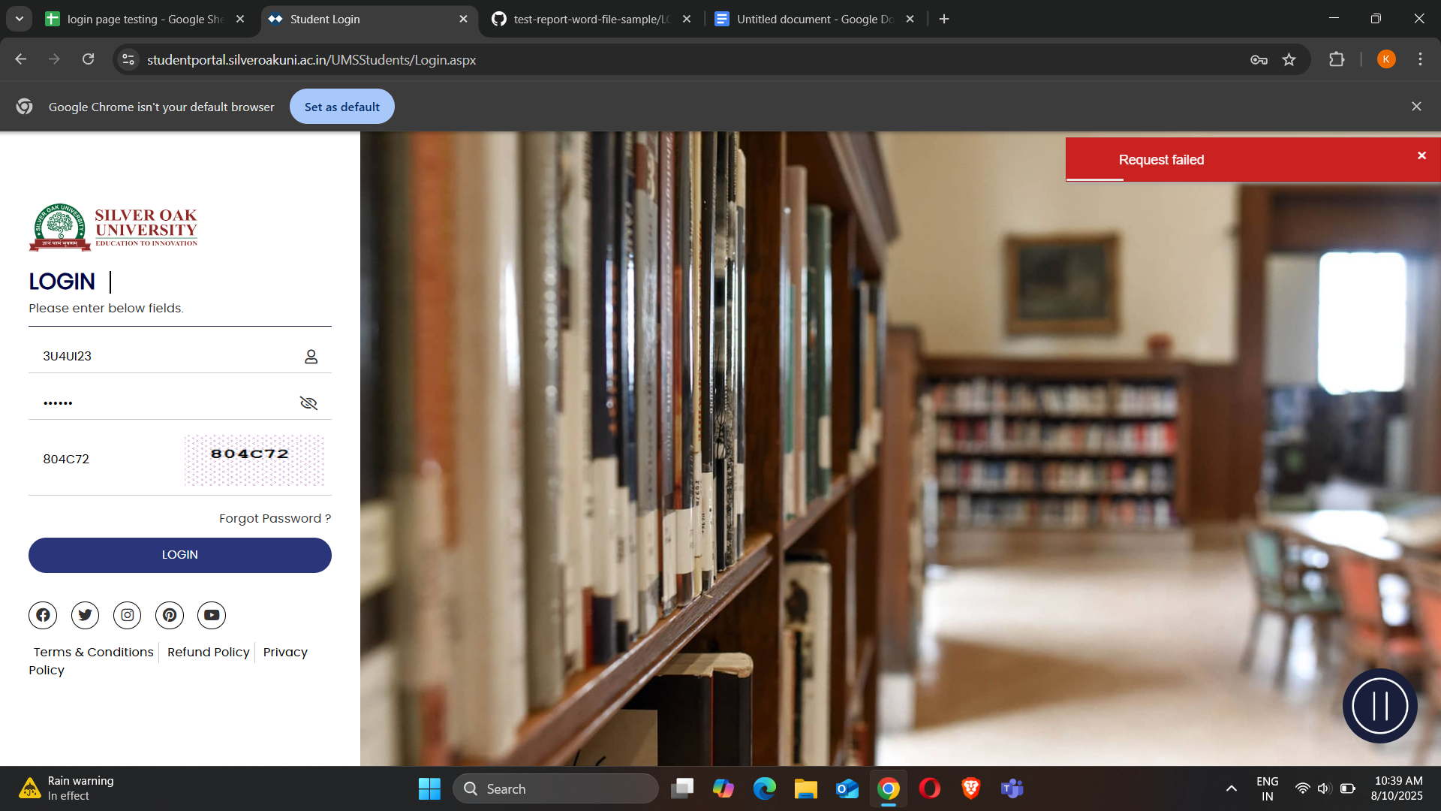

Scenario ID-3

| 1)Enter Username/Enrollment |
| --- |
| 2)Enter Password |
| 3)Enter wrong captcha |

SCREENSHOT’S

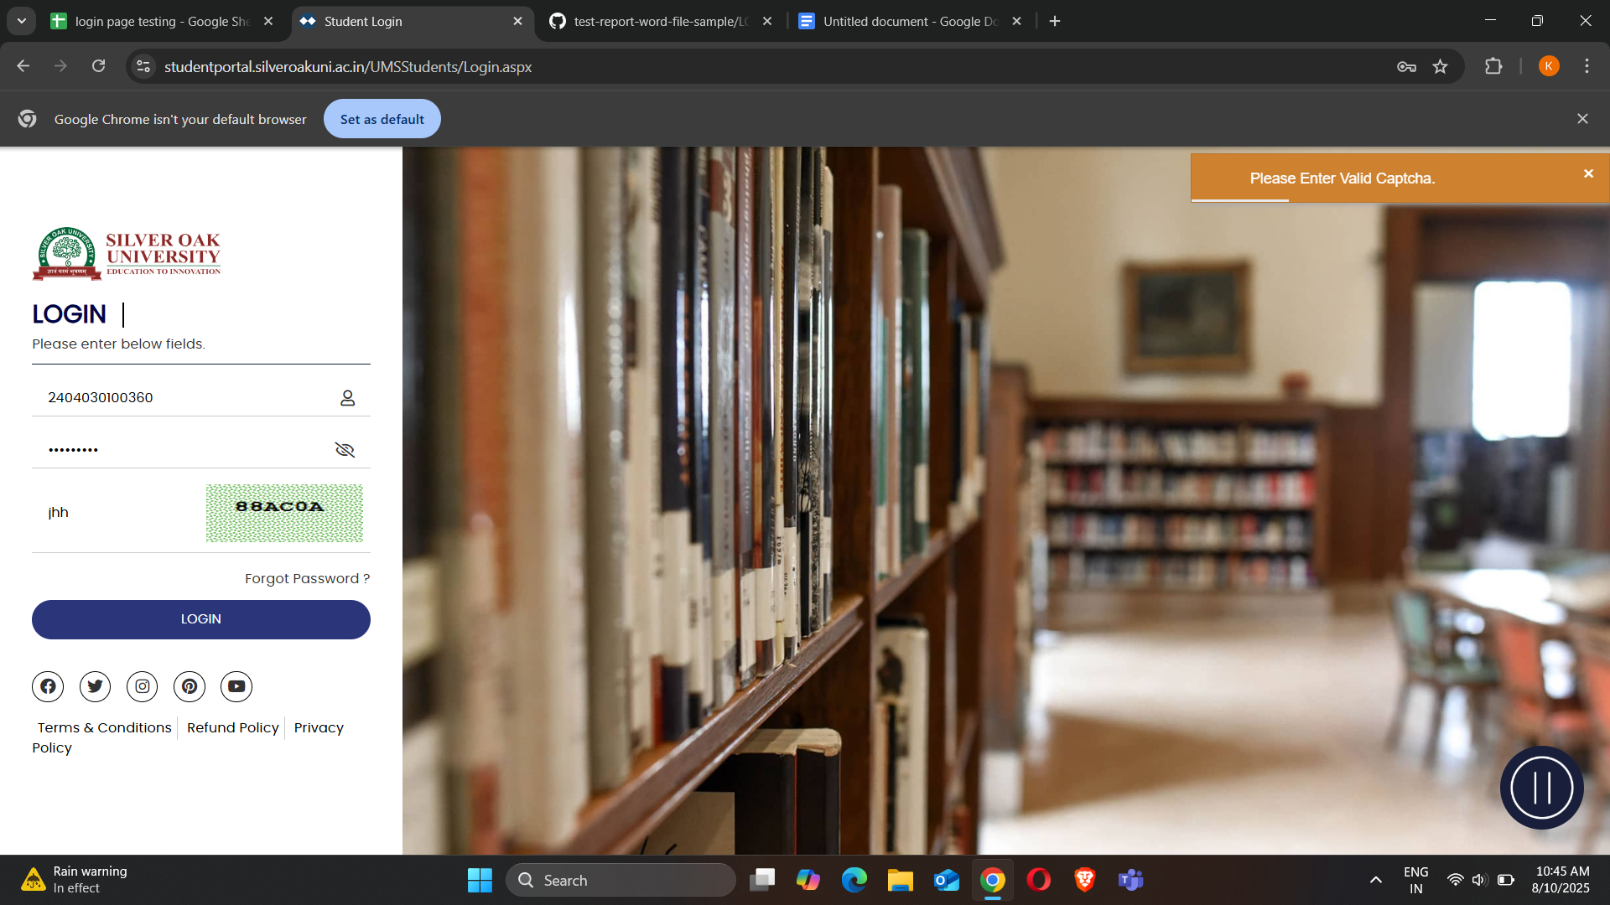

Scenario ID-4

| 1) Click on youtube redirect link |
| --- |
| 2) Click on instagram redirect link |
| 3) Click on pinterest redirect link |
| 4) Click on twitter redirect link |
| 5) Click on facebook redirect link |

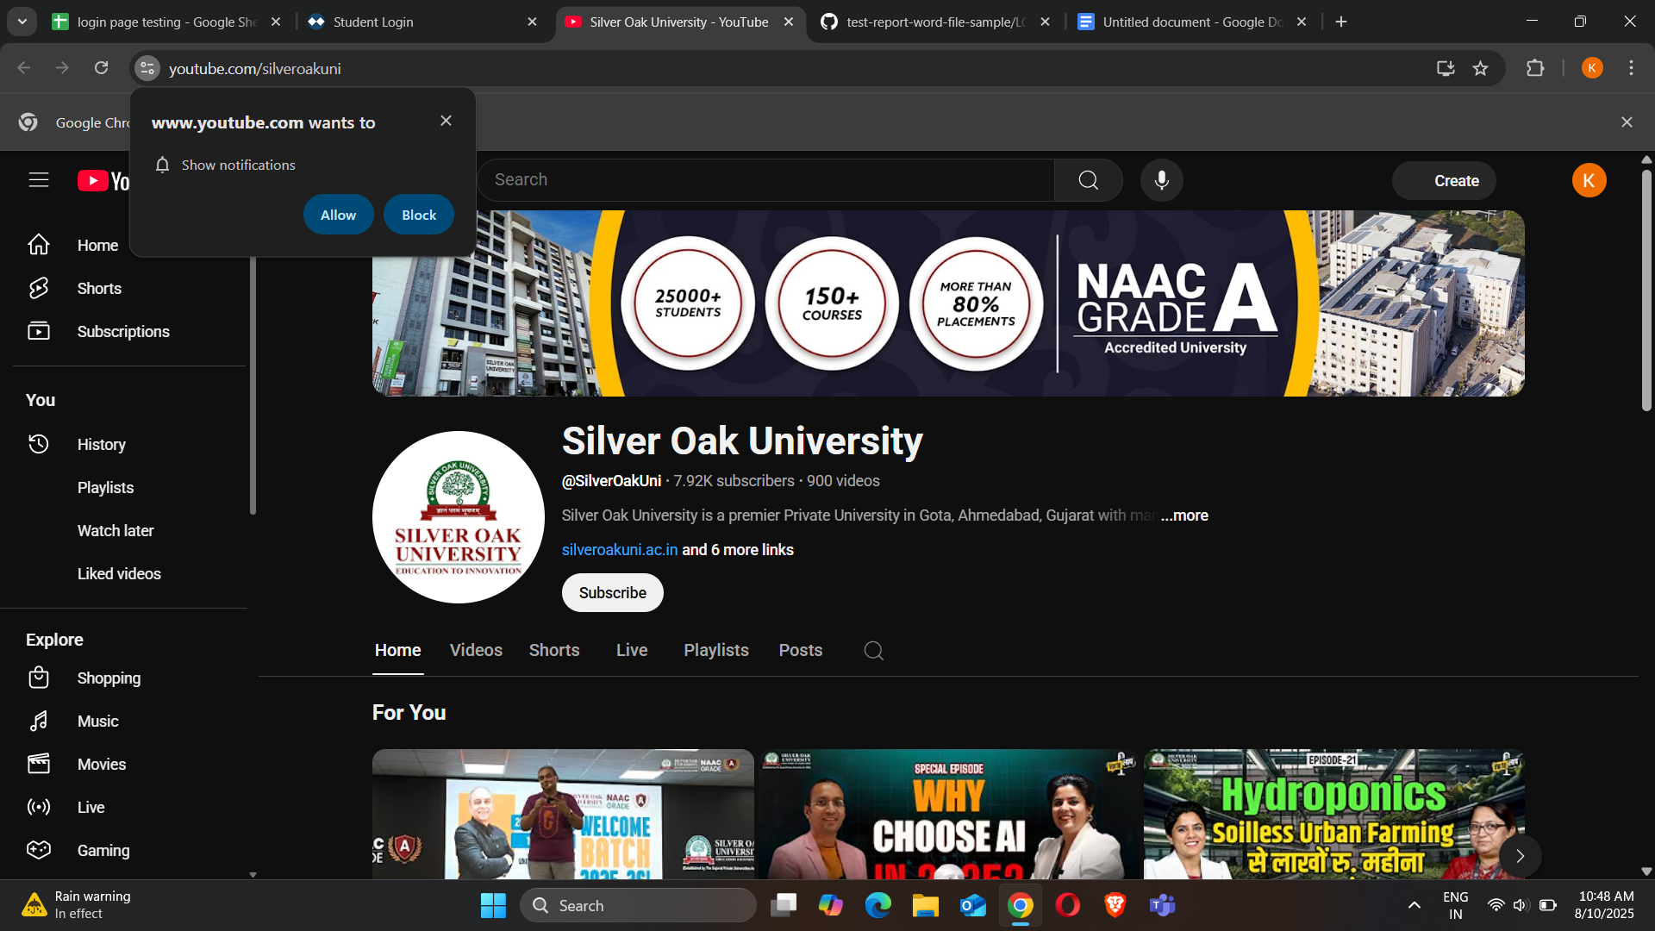

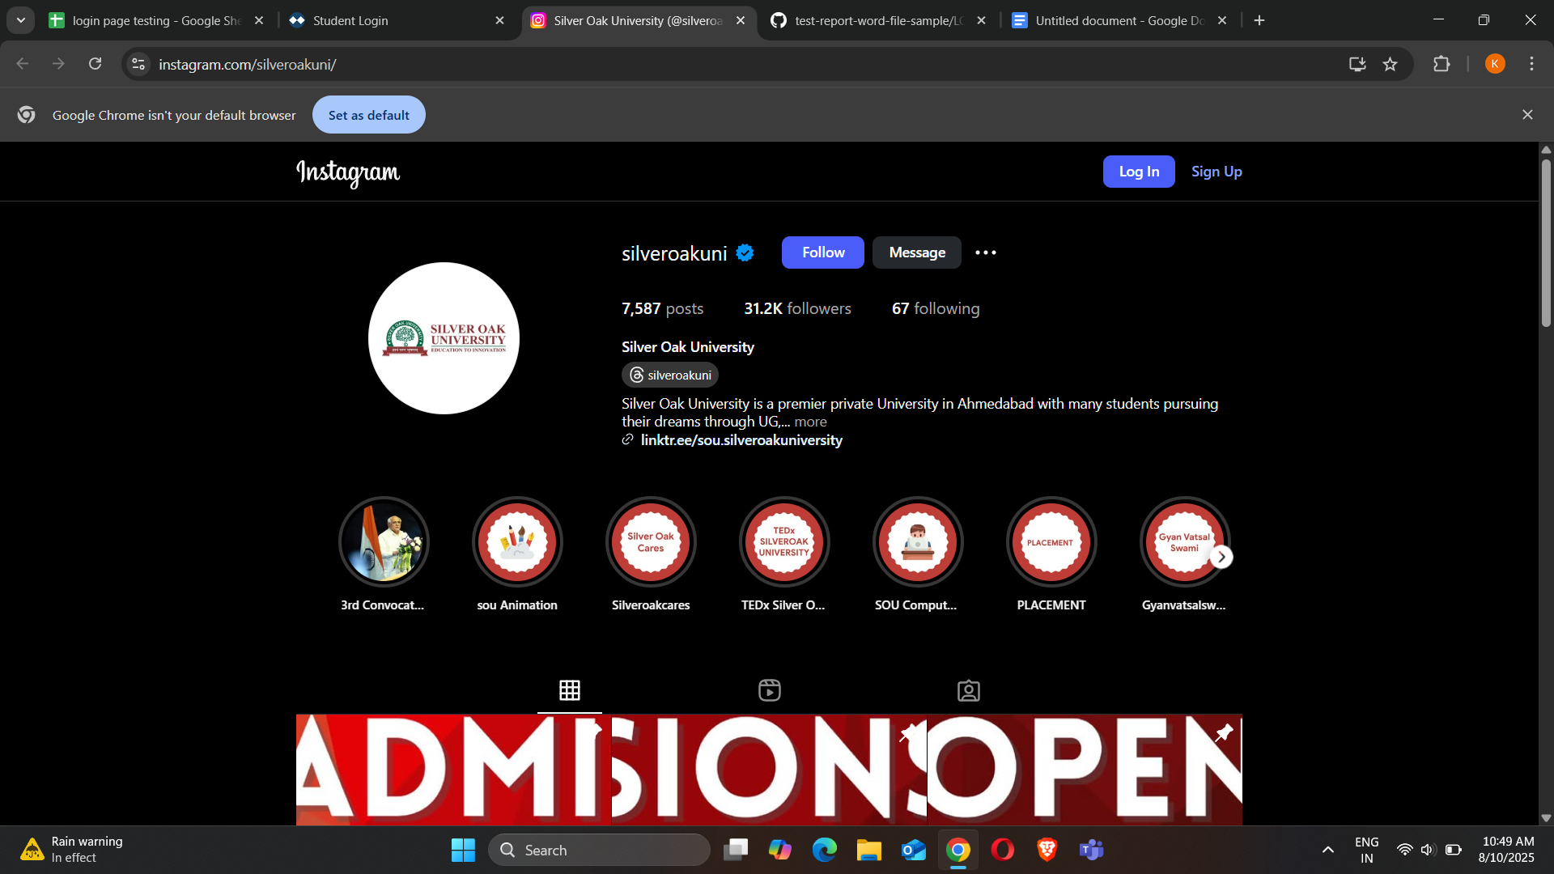

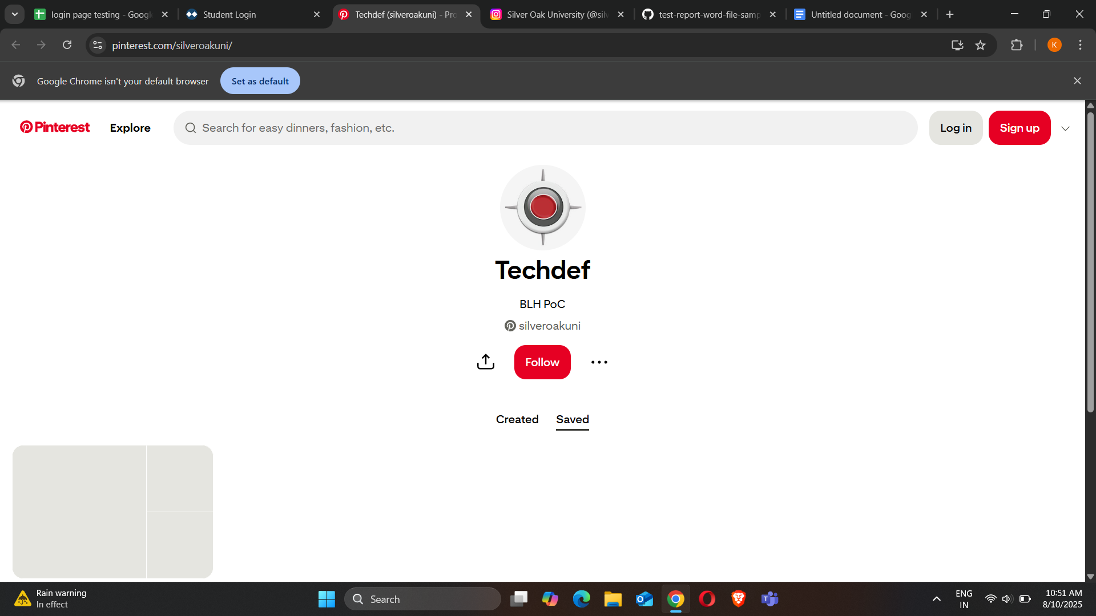

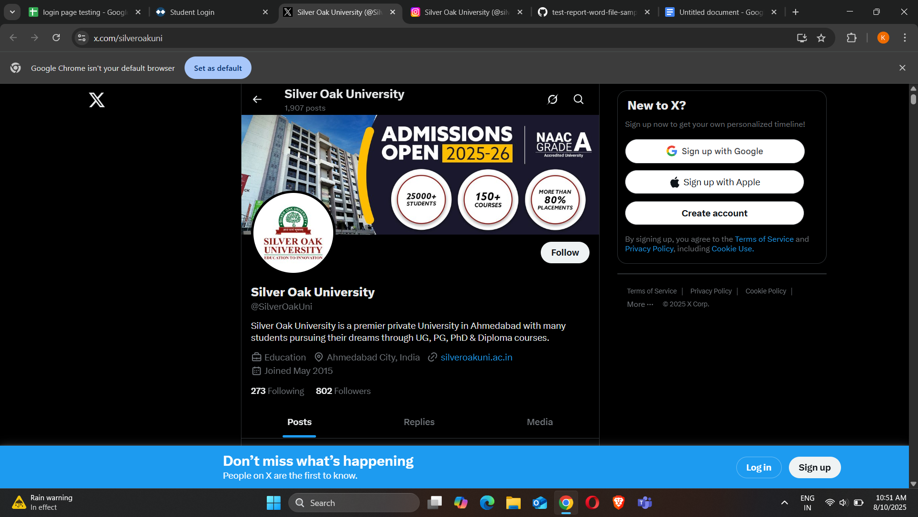

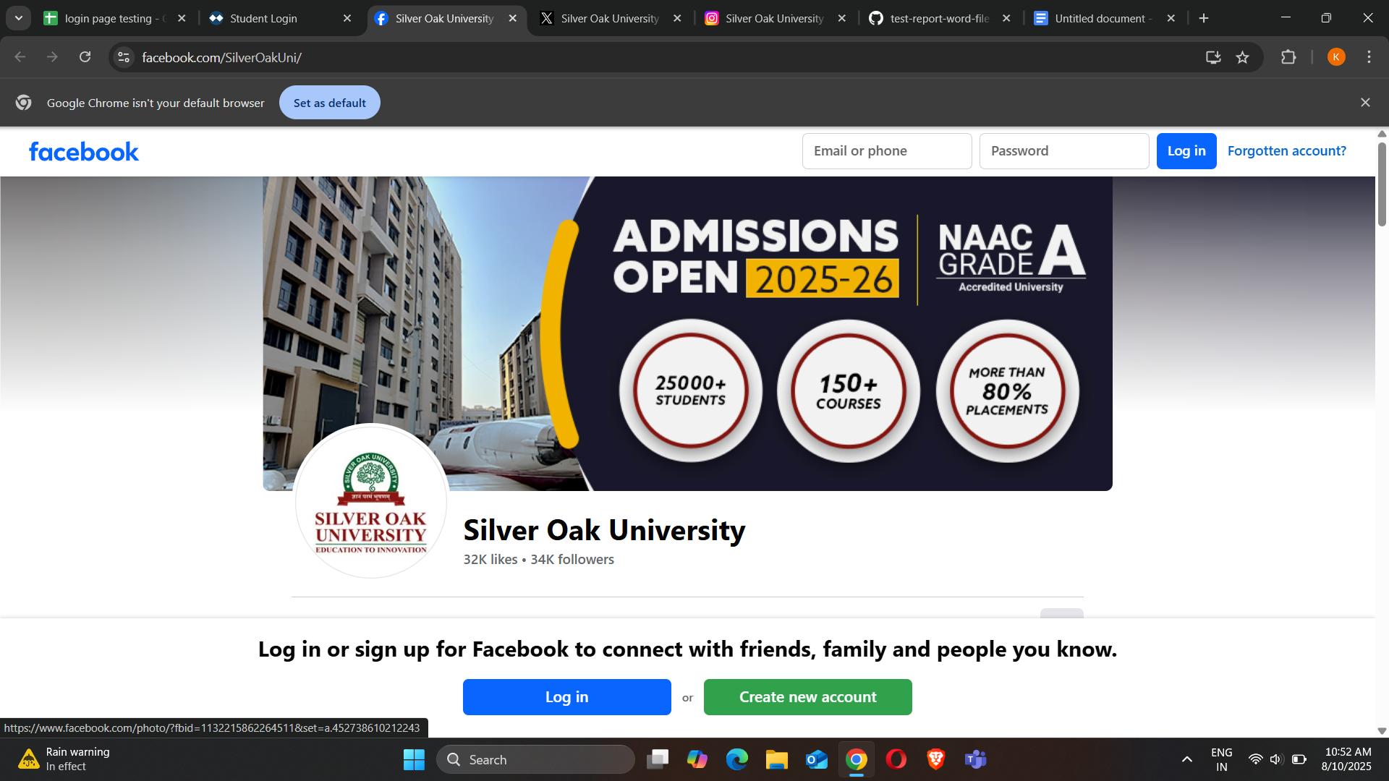

Scenario ID- 5

| 1) Click on terms and condition |
| --- |
| 2) Click on privacy policy |
| 3) Click on refund policy |

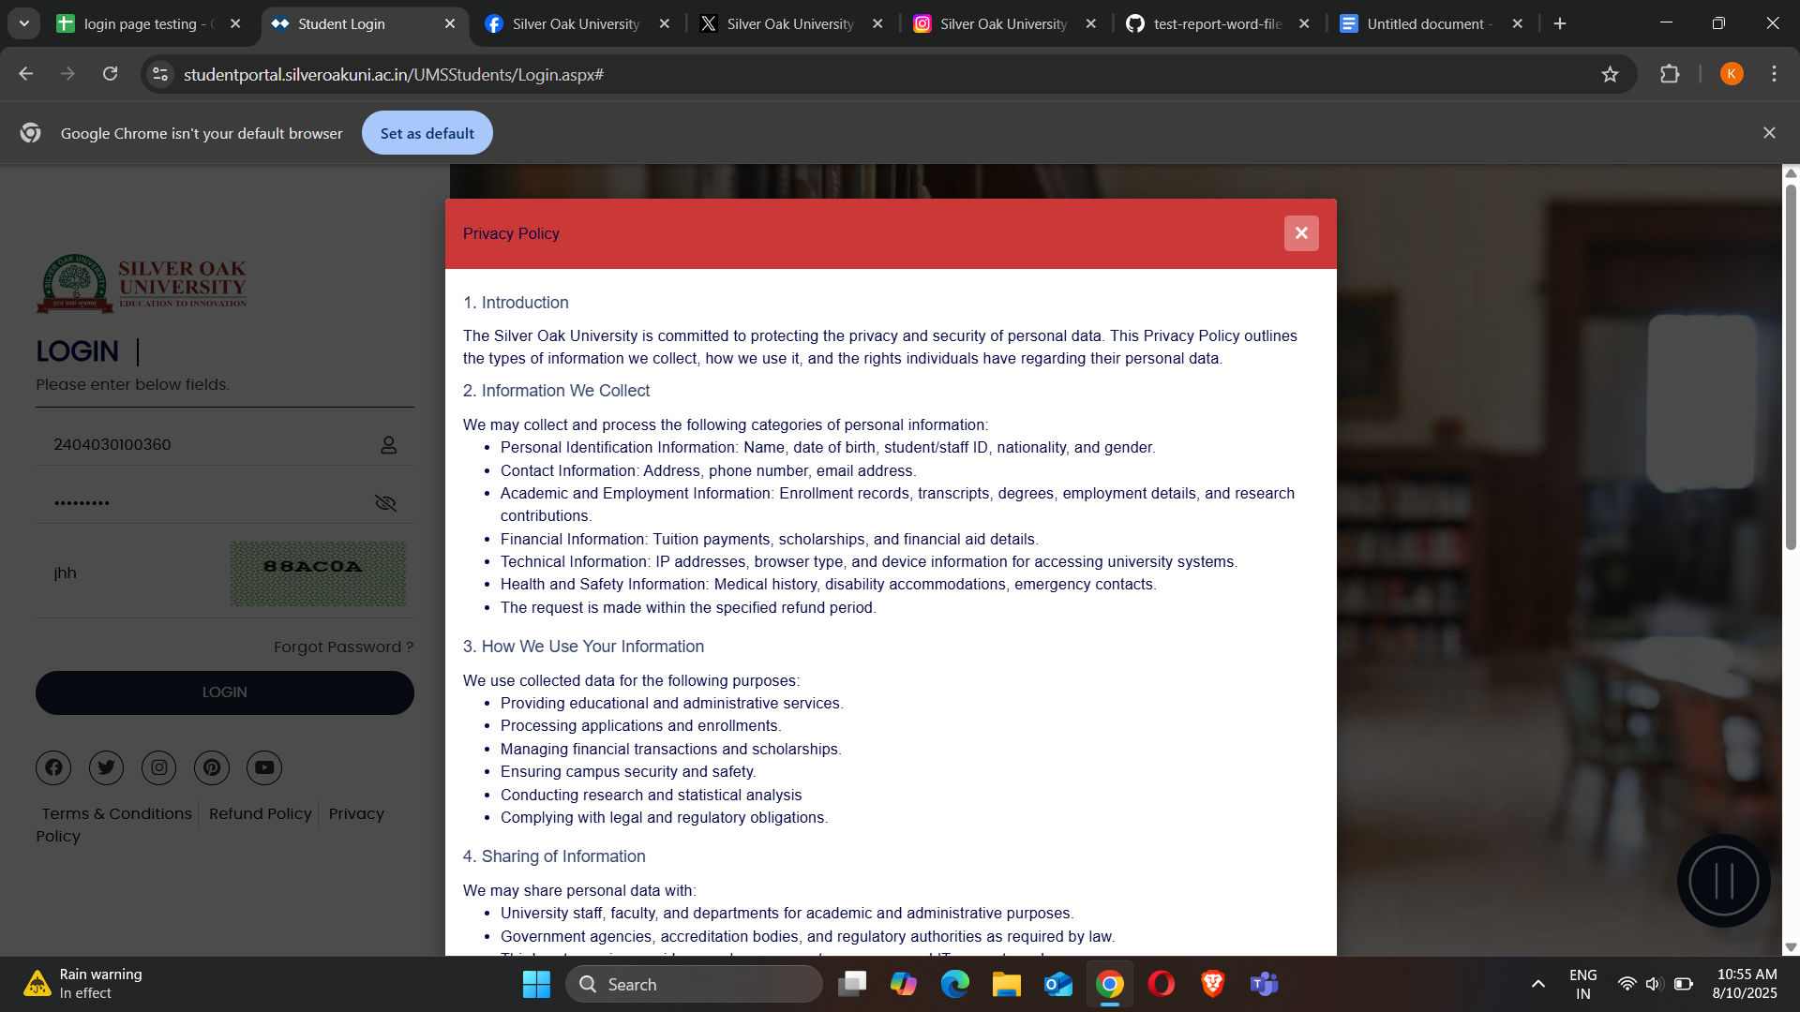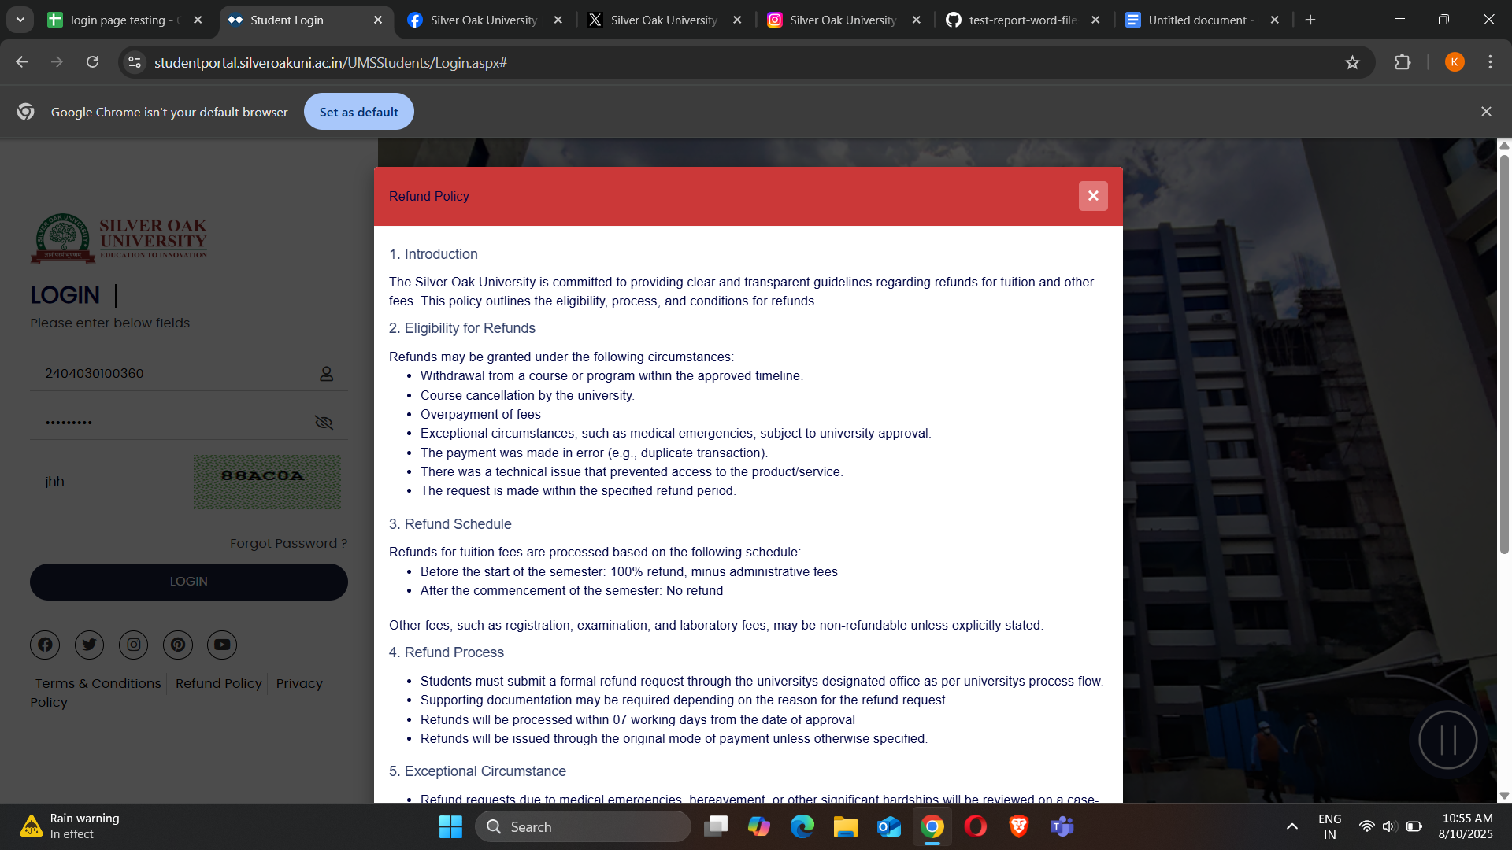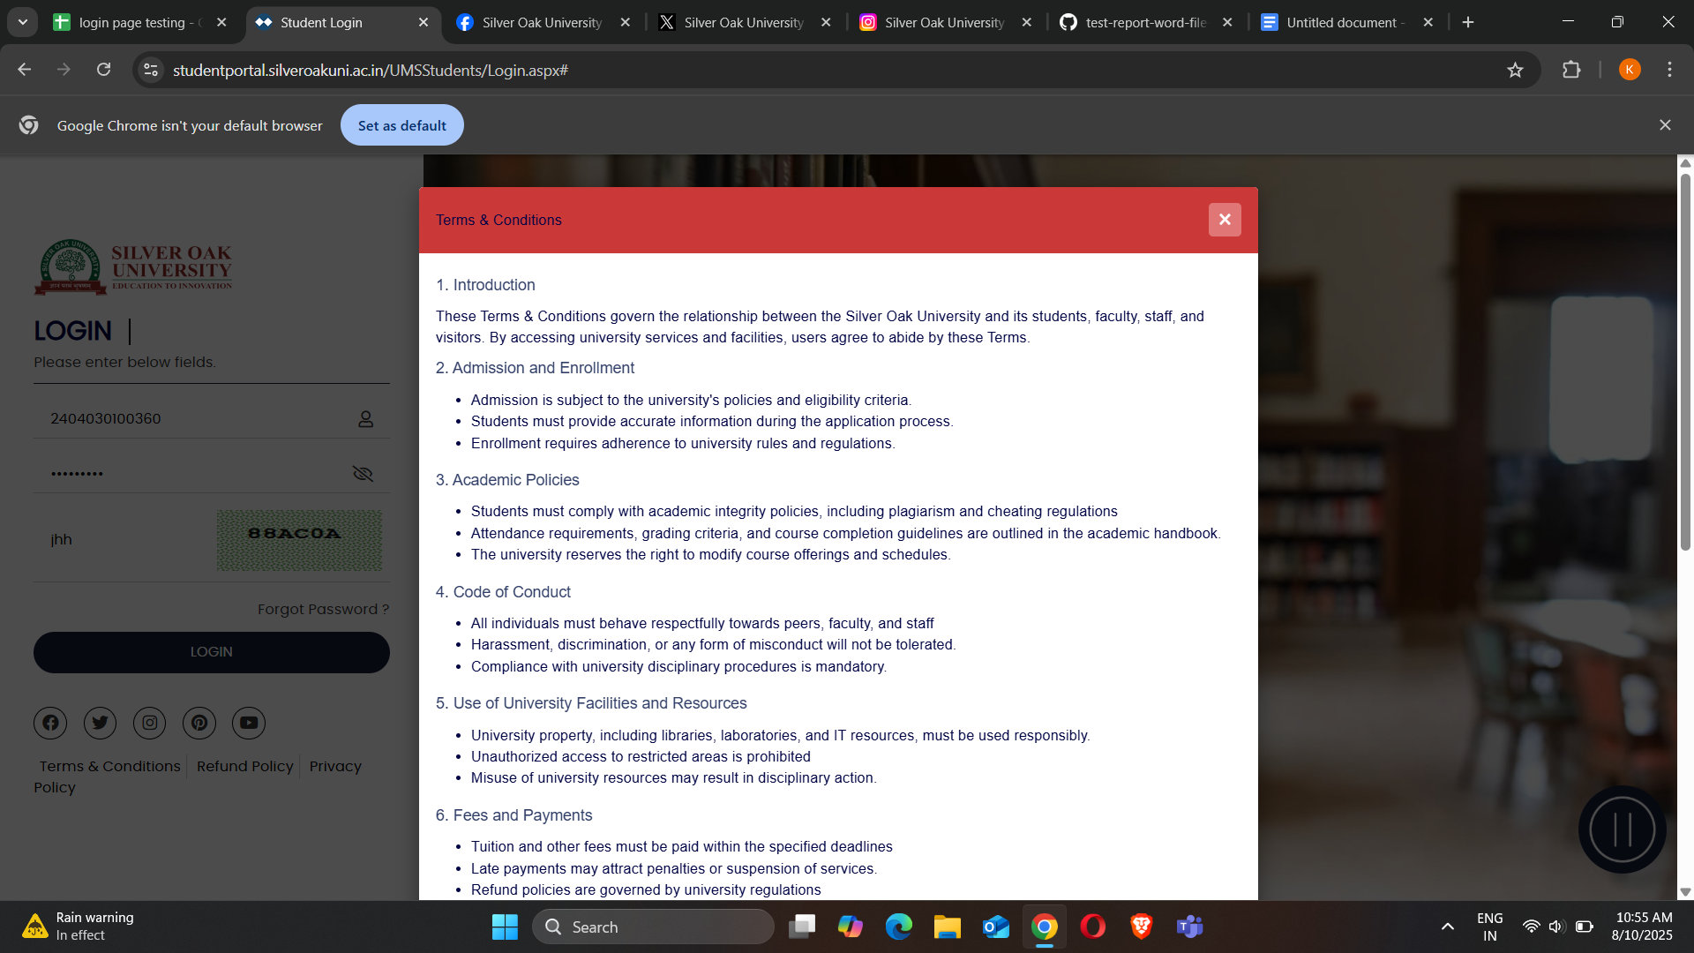

Scenario ID- 6

| 1) Forgot password verification |
| --- |
| 2) Successful receiving of OTP |

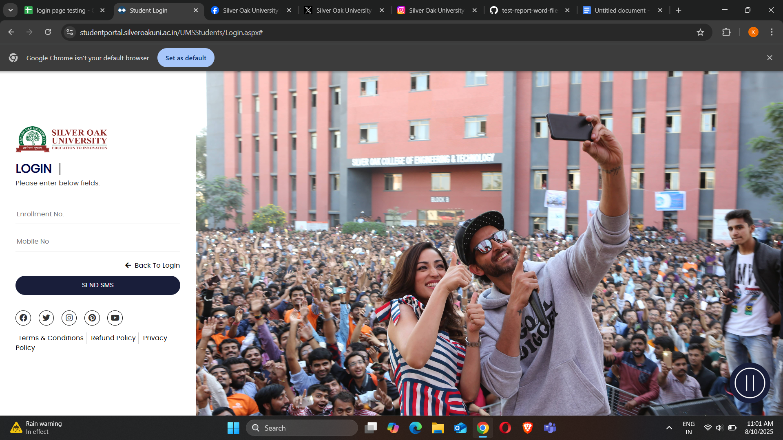

Scenario ID-7

Test new password working or not

